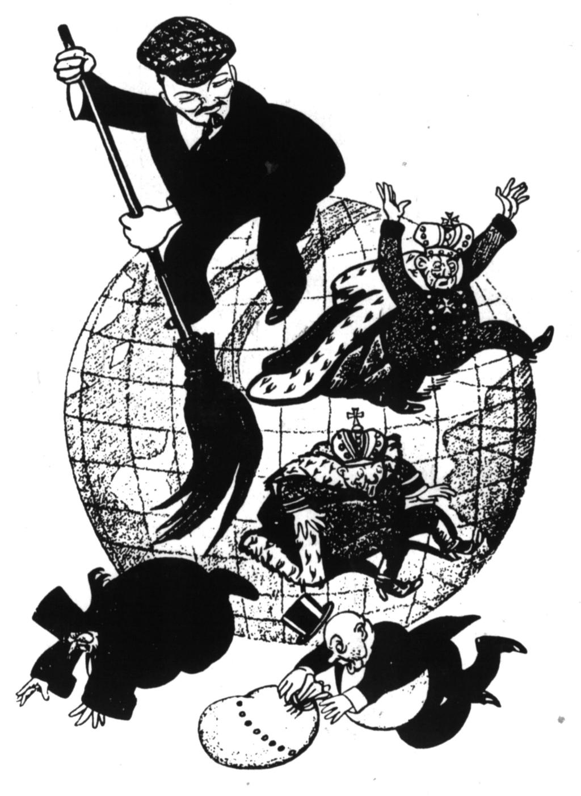
Origins of the Cold War
Tensions between East and West 1917-1939

Name: ____________________
(Understanding Causation in History)
Summary of Tension | Evidence (quote from text with page #)

