Historical Investigation 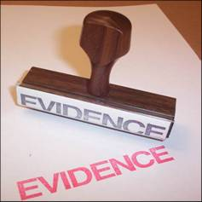
The IB History Internal Assessment

Student Guide

May 2010

Table of Contents for Diploma History HI Handbook 2008-2010

Focus Page Number

Front Page 1

Table of Contents 2

Outline of the Historical Investigation 3-4

Advice on your Historical Investigation Topic 5

Possible Topics for a Historical Investigation 6

Historical Investigation Ideas Sheet 7

Historical Investigation Source Ideas Sheet 8

An Example of Narrowing Down a Topic 9

Guidance on How to Structure an HI Question 10-11

Historical Investigation Proposal Form 12

A Research Notes Template Example 13

A Research Diary Example 14

Summary of Evidence Planning Table Example 15

Summary of Evidence Planning Table Template 16

First Draft Template for the Historical Investigation 17-18

Final Draft Checklist for the Historical Investigation 19

APPENDIX A: Assessment Criteria from 20-22
IB DP History Subject Guide

Historical Investigation
HL 20% SL 25%
Introduction

The historical investigation is a problem-solving activity which enables candidates to demonstrate the application of their skills and knowledge to an area which interests them and which need not be syllabus related. The emphasis must be on a specific historical enquiry tied to classroom activities that enables the candidate to develop and apply the skills of a historian, such as making sense of source material and managing conflicting interpretations. The activity demands that candidates search for, select, evaluate and use evidence to reach a decision or solve a problem. The investigation is not a major piece of research–candidates are only required to evaluate two of the sources they have used. However, these must be appropriate to the investigation and critically evaluated. The account should not be written up as an essay but in the style outlined later in this section. The internal assessment allows for flexibility and should encourage candidates to use their own initiative. Examples of the types of investigations candidates may undertake are:

• a historical topic or theme using written sources or a variety of sources

• a historical topic based on fieldwork; for example, a museum, archeological site, battlefields, churches

• a historical problem using documents (this could include newspapers)

• a local history project

• a history project based on oral interviews

• a historical investigation based on interpreting a novel, film, piece of art, for example.

Requirements

Candidates will be required to:

• undertake a historical investigation

• provide a title for the historical investigation which, in order to give focus and direction, may be framed as a question

• produce a written account, of between 1500–2000 words for HL and SL, which must consist of:

• an outline plan of the historical investigation
• a summary of evidence
• an evaluation of sources
• an analysis
• a conclusion.

The historical investigation will be internally assessed by the teacher and externally moderated by the IBO.

Choice of Topic

Candidates should choose their own topic, with the teacher’s guidance. The topic should be one that seems interesting and worthwhile to the candidate.

The teacher must approve the investigation before work is started, and must ensure that it complies with the regulations and is able to be assessed by the criteria for internal assessment.

Candidates must be aware of ethical considerations when undertaking any investigation. They must show tact and sensitivity, respect confidentiality and acknowledge all sources used.

The Written Account

Regardless of the type of historical investigation chosen, every candidate must produce a written account consisting of the following six sections:
A | Plan of the investigation | 3 marks
B | Summary of evidence | 6 marks
C | Evaluation of sources | 5 marks
D | Analysis | 6 marks
E | Conclusion | 2 marks
F | List of sources | 3 marks
Total |  | 25 marks

Plan of the investigation

The plan of the investigation should include:

• the subject of the investigation which may be formulated as a question

• the methods to be used in the investigation.

Summary of evidence

The summary of evidence should indicate what the candidate has found out from the sources he or she has used. It can be in the form of either a list or continuous prose. Any illustrations, documents, or other relevant evidence should be included in an appendix and will not be included in the word count.

Evaluation of sources
This section of the written account should be a critical evaluation of two important sources appropriate to the investigation and should refer to their origin, purpose, value and limitation. More than two sources may be evaluated but the emphasis should be on the thorough evaluation of two sources rather than a superficial evaluation of a greater number.

Analysis
The analysis should include:

• the importance of the investigation in its historical context

• analysis of the evidence

• if appropriate, different interpretations.

Conclusion
The conclusion must be clearly stated and consistent with the evidence presented.

List of sources
A bibliography or list of sources must be included although this will not form part of the word count.

Total: 1500–2000 words 25 marks
Advice on your Historical Investigation Topic

Below are some points that you need to think about in relation to your topic for the Historical Investigation:

Topic

Within certain limits, the topic will be for you to decide. It can be concerned with international, national, regional or local political, social, or economic issues or foreign policy. The selection of a topic should take into account the amount of material available and the scope for personal and individual investigation.

Structure

In parts of your Historical Investigation you will need to analyze and evaluate different historical points of view. To help you achieve this, the title for your Historical Investigation should be phrased as a question. In structuring such a question, you should consider the phrases “to what extent” or “how far”. What and how questions should be avoided because they foster a descriptive or narrative approach. For example, on the topic of the Origins of the Second World War, a good question would be:

To what extent did Hitler stumble into war in 1939?

A poorly phrased title for a Historical Investigation on the same topic would be:

What was Hitler’s foreign policy between 1933 and 1939?

You must also structure your Historical Investigation according to the structure laid out on page 4 and you should also read carefully the assessment criteria given in Appendix A at the back of this booklet.

Personal Interest

The Historical Investigation must be on a historical topic or issue that you are interested in or keen to find out more about. Your teacher will advise you and act as your tutor, but ultimately the effort, dedication and inspiration must come from you. This is why the choice of topic and the question is fundamentally crucial to a good Historical Investigation. Remember to also bear in mind that a well-produced Historical Investigation will set you up with a strong grade in the bag before you do your final examinations in May 2011.
Possible Topics for a Historical Investigation

Ultimately any time period in history can be the focus of your discussion but it is highly recommended that you select an area to focus on that you already have some background knowledge. A vast majority of previous historical investigations have been exploring a topic drawn from our SL or HL syllabus but it is not a requirement.

In the most recent IB Support Guide for History Teachers included 5 possible topics:

- How do the earlier interpretations of jihad during the Medinan period of the Prophet Muhammad’s life differ from modern interpretations of the term as used by radical Islamic militant groups?
- How did the Women’s Coastguard Reserves of World War II change the role of women in the US military?
- To what extent did the cooperation between the Allied and the Mafia during the Allied invasion of Sicily in the Second World War contribute to the re-establishment of Mafia control in Sicily, after Mussolini’s attempt to reduce them?
- Afghanistan and the United States connection: To what extent did the anti-communist policies of the United States contribute to the rise of the Taliban?

I have copies of these with accompanging marks if you want to peruse them. I also have guides from 2007, 2004, 2002 that each have samples of previous work. Some of these are marked under an old mark scheme but they still can be inspirational.

Here are a few places to look for ideas for research questions.

- History Today (the library has 4-5 years of back issues with some really fascinating topics that could be used to draw a tangent from)

- International School of Toulouse Gallery of Past Investigations

http://www.internationalschooltoulouse.net/ibhistory/coursework/internal_assessment/index.htm

- Casahistoria is a great website that is tailored for students of history that might also be a good place to find research. http://www.casahistoria.net/

Historical Investigation First Thoughts Sheet

Fill in this sheet to help you start thinking about your historical investigation. Think carefully about your answers:

Circle the option for you:

1) Which period of History interests you mainly?

Ancient (before 500 BC) Medieval (500-1500BC) Modern (1500BC+)

2) Which part of the world do you want to find out about?

Middle East Europe Asia Africa Americas Australasian

3) What sort of History are you interested in?

Political Economic Social Military Local

4) What sources would you like to compare and contrast?

Novels Diaries Newspapers Feature Films Art History Books

5) Which of the below topics, or subtopics within them, that you have studied to date did you go: “hmmm, that is interesting…..”

WWI Peace Negotiations/League of Nations Taiping Rebellion Opium War

6) Write down a list of possible areas of interest:

Historical Investigation Source Ideas Sheet

The most important part of your historical investigation is finding two sources that provide conflicting interpretations of the same event. These do not always have to be in the form of history books. They can be works of literature, personal diaries, detailed posters and even films. Look at the examples below that you could use to help in your historical investigation e.g.

Literature:
George Orwell – “Animal Farm” (Russia 1917-1945)
Harper Lee – To Kill a Mockingbird (Racial discrimination in the United States)
George Orwell – “The Road to Wigan Pier” (Britain in the 1930’s)
Erich Maria Remarque – “All Quiet on the Western Front” (World War One)
George Orwell – “1984” (Totalitarian regimes)
Jung Chang – “Wild Swans” (20th Century China)
William Shakespeare – “Julius Caesar” (Roman Empire)
E.M.Forster – “A Passage to India” (British India between WW1 and WW2)

Film:

JFK – Murder of John F Kennedy
Thirteen Days – Cuban Missile Crisis
Saving Private Ryan – D-Day Landings
Schindlers List – Holocaust
Saladin – Saladin (Arabic Film)
Apocalyse Now – Vietnam (There are many on this conflict)

You could compare each of these sources to a more standard historical book on an issue in the work of fiction or feature film.

You may be better able to think of some a topic from your personal heritage/national history you may want to do. Be aware though of the importance or accessing the necessary sources.
An Example of Narrowing Down a Topic
Taken from http://www.historyguide.org/guide/image.html

“You also need to look at your topic realistically. Obviously, no one would contemplate a topic so broad as “A History of Europe, 1648-1996,” for an essay only twenty pages in length. Not only could you not condense 350 years of European history in twenty pages, fifteen weeks is hardly enough time to do the research for a longer study, even if it were possible.

If you know very little about your topic, your first task is obviously to learn more. Suppose your general topic is the Age of Enlightenment. This a broad topic. Consult an encyclopedia. You will run across names (Diderot, Rousseau, Voltaire, Paine), events (Lisbon Earthquake, French Revolution), and ideas (11kepticism, deism, liberty). Perhaps one of these things strikes your fancy. Suddenly, you find yourself attracted to Tom Paine’s essay The Age of Reason, in general, and his ideas on deism in particular. You begin to ask yourself questions: who was Tom Paine? What is deism? Who were the deists? Why did deism appear when it did? What effect does deism have on the movement for parliamentary reform in England in the 1790s? Then, for whatever reason, you are led to an entirely different topic, say, English political radicals in the age of the French Revolution.

Through your discovery of Paine’s Rights of Man, you encounter the radical philosopher William Godwin. He was an anarchist which is odd because he was writing at a time (1790s) when most English radicals were trying to reform Parliament, not abolish it altogether. You then thumb through a brief biography of Godwin and soon discover that he married Mary Wollstonecraft, an out-spoken feminist who wrote the first critique of Edmund Burke’s Reflections on the Revolution in France (Paine’s Rights of Man was a response to Burke’s Reflections as well). You also find out that Godwin and Wollstonecraft produced a daughter, Mary, who later married Percy Bysshe Shelley, and wrote Frankenstein. Quite a jump from your first initial interest in Paine’s deism, isn’t it? And all of this could have taken place in a week or two. I mention this example because using this same technique, I arrived at a topic for seminar paper which happened to be about the notion of human perfectibility in the thought of William Godwin.”
Guidance on How to Structure an HI Question
Adapted from Historians’ Fallacies by David Fischer

An essential skill of the historian is the ability to ask questions. While this may seem like an easy task, it may in fact be one of the most difficult. A historian is someone who asks an open-ended question about past events and answers it with selected evidence that is arranged in an explanatory way. “Questions are the engines of intellect … which convert energy to motion, and curiosity to controlled inquiry.” (3)

There are five general characteristics that a good historical question should have:

1. It must be resolvable with measurable (empirical) evidence

2. It must be open-ended

3. It must be flexible and open to endless refinement

4. It must be explicit and precise

- It must be tested

The following assignment will try to identify some of the common problems in asking historical questions.

Types of fallacies

- Too large of a scope: What happened during World War 1?

The problem with this question is that it is so broad and that there is so much information on the question that it becomes impossible to answer correctly. In order to have a proper focus one needs to start with a reverse pyramid approach to questioning.

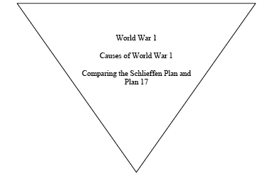

2. Non-question which sets out to prove an existing opinion

The historian cannot set out to prove something s/he has already concluded to be true. If you begin your inquiry with the conclusion that “X was the case” than you will simply be trying to find evidence to support your case not trying to discover historical truth. This can also be affected by the sources that you choose to gather your evidence from. If you try to answer your question by only looking at sources from one perspective, your question will not be answered.

3. Too many questions

This fallacy of questioning involves framing a question that makes false presumptions. The classic example of this type of a question is “Have you stopped beating your wife?” A historical example is “What were the US’ primary motives for dealing with Hussein” This assumes that there were in fact primary motives and therefore assumes that simple answers will be identified and explained. In fact there may be no simple answer to the question. Another example is “Why are all radical revolutions violent?”

4. A question that demands a choice between two answers, which are in fact not exclusive or not exhaustive.

This type of question assumes that there is no choice between two opposites. It is also called either or thinking. It assumes that there are no other options or that there is no middle ground between the two positions. For example, questions like: “The Fall of the Russian Monarchy- Inherent Failure or Planned Revolution?” assumes only two options are available. It also assumes that there is somehow a relationship between the two ideas and that both ideas are mutually exclusive.

- The abstract or metaphysical question

This is the failure in which a non-empirical problem is attempted to be solved by empirical means. For example “Why was Lincoln shot?”
“Was the Korean War inevitable?” When posing a why question, the historian must be careful to define what s/he is trying to determine. Is the why to determine the motive, reason, is a description of possibilities, a historical process, the purpose behind the action, or a justification. Why questions on there own lack direction, clarity and need to be carefully thought through.

- What if questions

This is where the historian attempts to explain through empirical evidence what might have happened in history, if in fact it actually had. While what if questions are very interesting and can serve to help clarify historical events they ultimately prove nothing and cannot be viewed as the same as historical evidence. For example, what would have happened if the Nazi’s had developed the atomic bomb first? All historical evidence for what might have happened is necessarily taken from the world in which the Nazi’s did not develop the bomb first. There is no way to escape this fundamental fact, therefore any records or evidence used are immediately counterfactual.

History Investigation Proposal Form

Topic/Question

Justification about why I want to study this Topic/Question

A list of five sources (fully referenced) that I have found already and will prove useful.

Two sources that I could use for Section C. Justification for why I think they are useful for Section C.

The below sheet is a suggestion of a format for your research journal. You will each be expected to keep a clear record of each source that you consult in your research diary and have a research page where you take notes. You will be checked periodically. (read: LIVE IN FEAR!!! ☺)
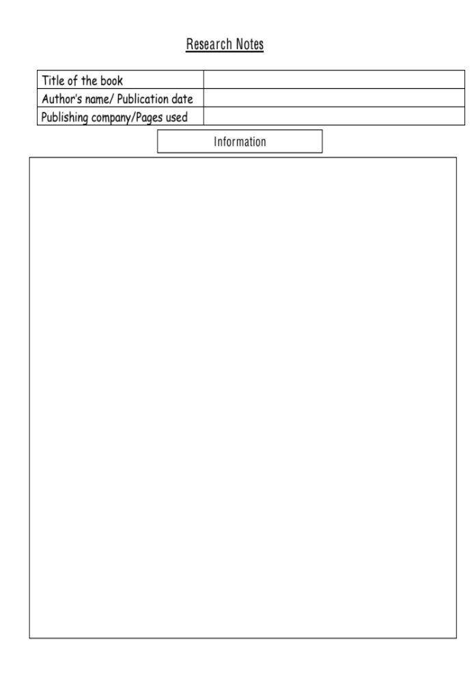
Research Diary Template

Date | Time Spent | Median of Research | What did you learn from this source? | Where are you going to go next?

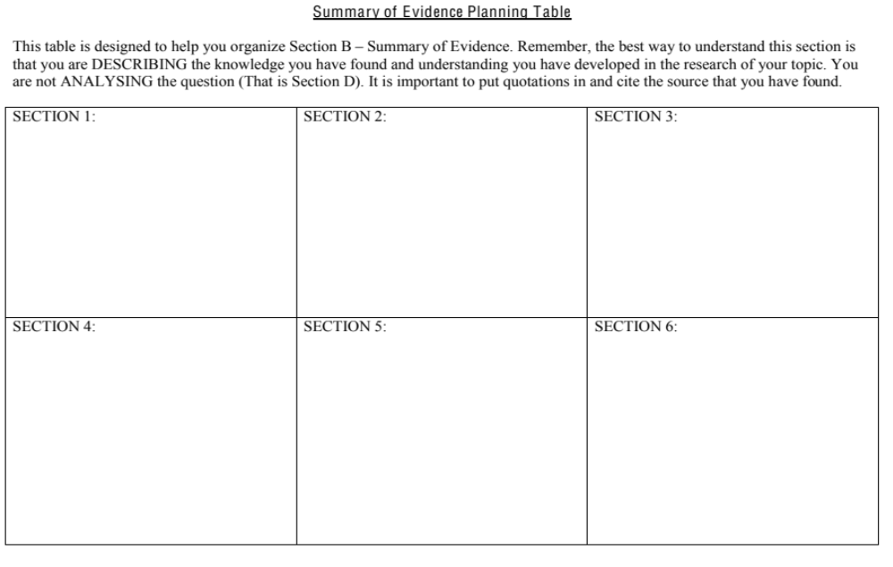

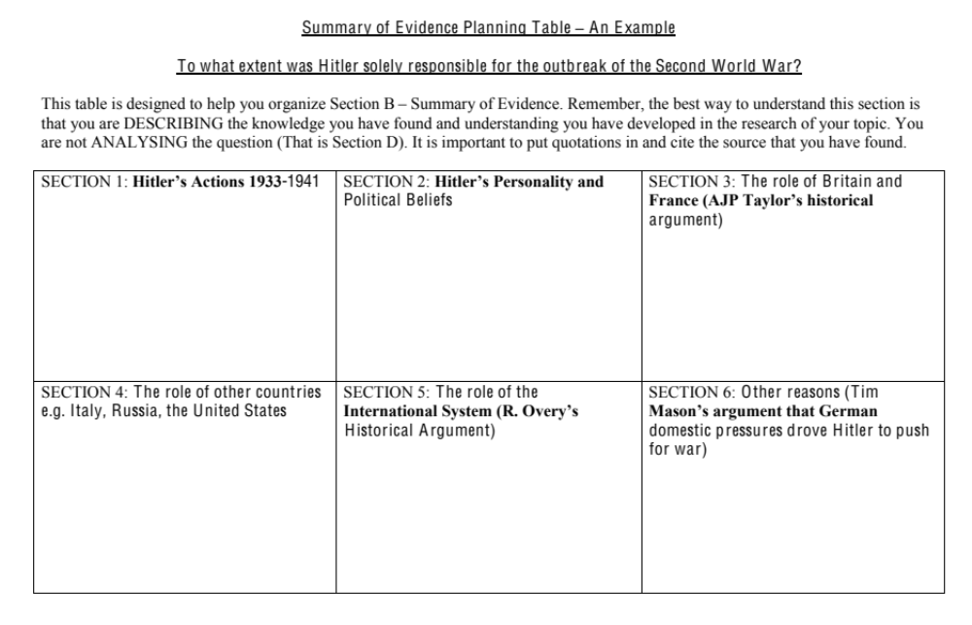

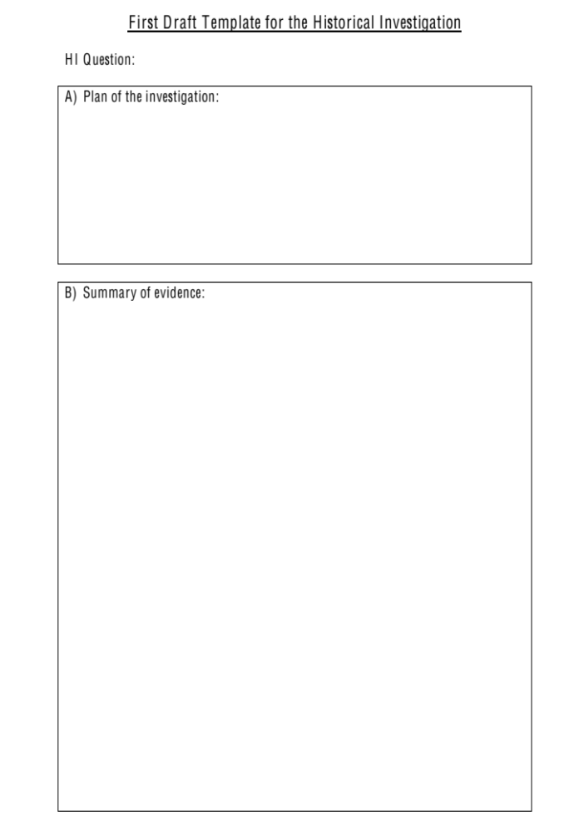

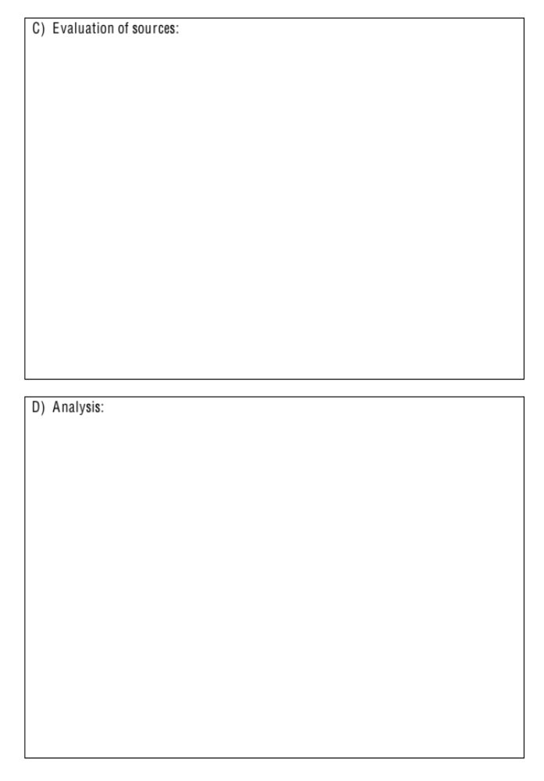

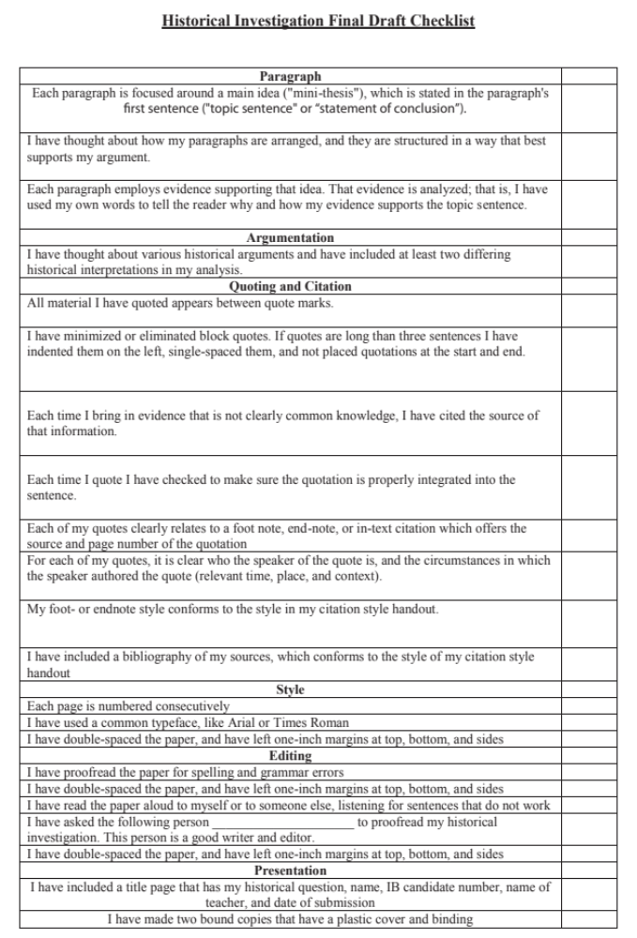

Appendix A: Assessment Criteria


